CREATE (:Type {name: "Música"}), (:Genre {name: "Rock"}), (:Genre {name: "Rap"}),

(:Artist {name: "Xavibo", from: "Islas Baleares, España"}),

(:Group {name: "Deep Purple", from: "Hertford, Reino Unido", formed: 1968, actualMembers: "Ian Gillan, Steve Morse, Roger Glover, Don Airey, Ian Paice", formerMembers: "Jon Lord, Rod Evans, David Coverdale, Joe Lynn Turner, Ritchie Blackmore, Tommy Bolin, Joe Satriani, Nick Simper, Glenn Hughes"}),

(:Group {name: "Queen", from: "Londres, Reino Unido", formed: 1970, formerMembers: "Freddie Mercury, Brian May, John Deacon, Roger Taylor, Mike Grose, Barry Mitchell, Doug Bogie"}),

(:Song {name: "Highway Star", released: 1972, duration: "6:05", album: "Machine Head", trackNumber: 1}),

(:Song {name: "Maybe I'm a Leo", released: 1972, duration: "4:51", album: "Machine Head", trackNumber: 2}),

(:Song {name: "Pictures of Home", released: 1972, duration: "5:03", album: "Machine Head", trackNumber: 3}),

(:Song {name: "Never Before", released: 1972, duration: "3:56", album: "Machine Head", trackNumber: 4}),

(:Song {name: "Smoke on the Water", released: 1972, duration: "5:40", album: "Machine Head", trackNumber: 5}),

(:Song {name: "Lazy", released: 1972, duration: "7:19", album: "Machine Head", trackNumber: 6}),

(:Song {name: "Space Truckin", released: 1972, duration: "4:31", album: "Machine Head", trackNumber: 7}),

(:Song {name: "Black Night", released: 1970, duration: "3:28", album: "Single", trackNumber: 1}),

(:Song {name: "Intro", released: 2016, duration: "2:11", album: "CHROMATIC", trackNumber: 1}),

(:Song {name: "Alivio", released: 2016, duration: "2:26", album: "CHROMATIC", trackNumber: 2}),

(:Song {name: "Trece", released: 2016, duration: "2:58", album: "CHROMATIC", trackNumber: 3}),

(:Song {name: "American Beauty", released: 2016, duration: "2:41", album: "CHROMATIC", trackNumber: 4}),

(:Song {name: "Abstracto", released: 2016, duration: "3:26", album: "CHROMATIC", trackNumber: 5}),

(:Song {name: "Quiéreme de lejos", released: 2016, duration: "2:45", album: "CHROMATIC", trackNumber: 6}),

(:Song {name: "Amor sin mezclar", released: 2016, duration: "3:29", album: "CHROMATIC", trackNumber: 7}),

(:Song {name: "Ceniza", released: 2019, duration: "2:34", album: "Summer without you"})

MATCH (a:Song), (b:Group)

WHERE a.album = "Machine Head" AND b.name = "Deep Purple"

CREATE (b)-[:INTERPRETA]->(a)

MATCH (a:Song), (b:Group)

WHERE a.name = "Black Night" AND b.name = "Deep Purple"

CREATE (b)-[:INTERPRETA]->(a)

MATCH (a:Song), (b:Artist)

WHERE a.name = "Ceniza" AND b.name = "Xavibo"

CREATE (b)-[:INTERPRETA]->(a)

MATCH (a:Song), (b:Artist)

WHERE a.album = "CHROMATIC" AND b.name = "Xavibo"

CREATE (b)-[:INTERPRETA]->(a)

MATCH (a:Type), (b:Artist)

CREATE (b)-[:HACE]->(a)

MATCH (a:Type), (b:Group)

CREATE (b)-[:HACE]->(a)

MATCH (a:Type), (b:Genre)

CREATE (a)-[:GENERO_DE]->(b)

*//HASTA AQUÍ, EL GRAFO QUEDA ASÍ:*

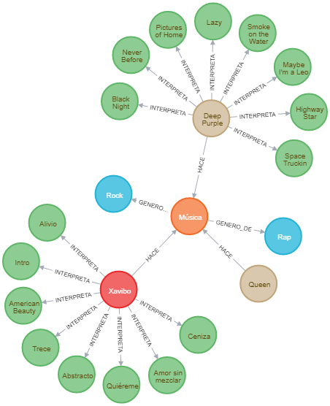

*//SIGUIENTE PASO: ESTUDIAR RELACIÓN ENTRE CANCIONES/ARTISTAS Y GÉNERO*

.